ISDN
Digitising of the telephony-networks offered the chance to integrate all existing telecommunication services (voice and data services) to one network.
The Integrated Services Digital Network
ISDN offers circuit-switched connections (for either voice or data) in increments of 64 kbit/s, and packet-switched connections (for data).
Prior to ISDN a packet switched network named X.25 was the preferred network for data transmission. For example cash dispenser use X25 access. ISDN now offers access to the X.25 Network via the telephone line.

Types of ISDN access
:
- Basic rate access 2B+D
2x 64kb/s B + 1x 16kb/s D
Basic rate access offers two circuit switched bearer channels 64kb/s each plus one packet switched data channel with 16kb/s
The D-channel is also used to transfer the messages necessary for call set-up and management of the circuit switched B-channels.
- Primary rate access 30B+D
30x64kb/s B + 1x 64kb/s D
Primary Rate access offers 30 circuit switched bearer-channels 64kb/each plus one packed switched data-Channel with 64kb/s

OSI-layers:
ISDN-standards are organized as the OSI-Layer model.
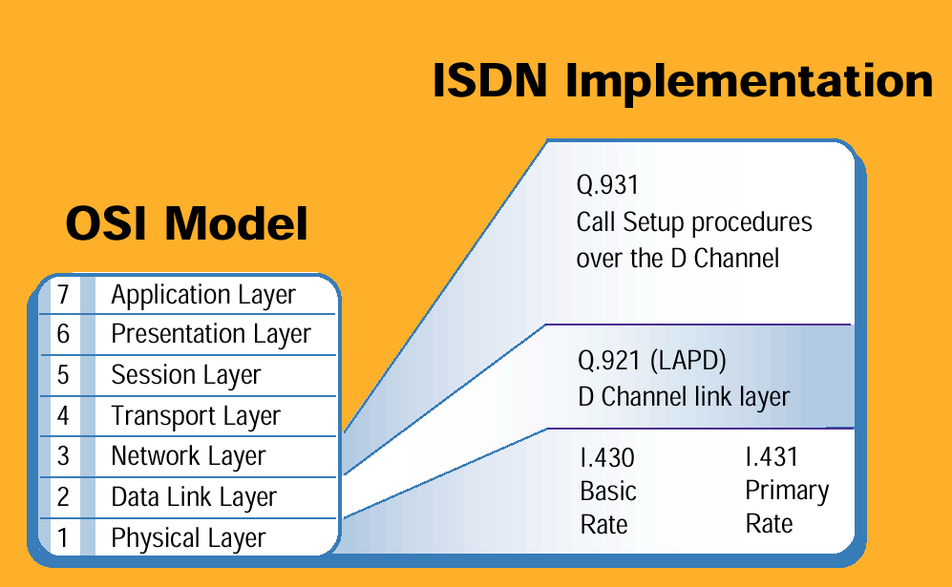
Layer1 (Physical Layer)
defines electrical and mechanical properties of the ISDN-interface like
Plug, voltages bit rates and transmission code used
Layer 2 (Data link layer)
defines the data packet structure in the D-Channel
A protocol named HDLC is used in Layer 2.
Layer 3 (Network Layer)
Layer defines the protocol used for call set up using layer 2 packets sent from the Telephone to the central switch and vice versa.

Physical layer (Layer1)
Basic rate interface:

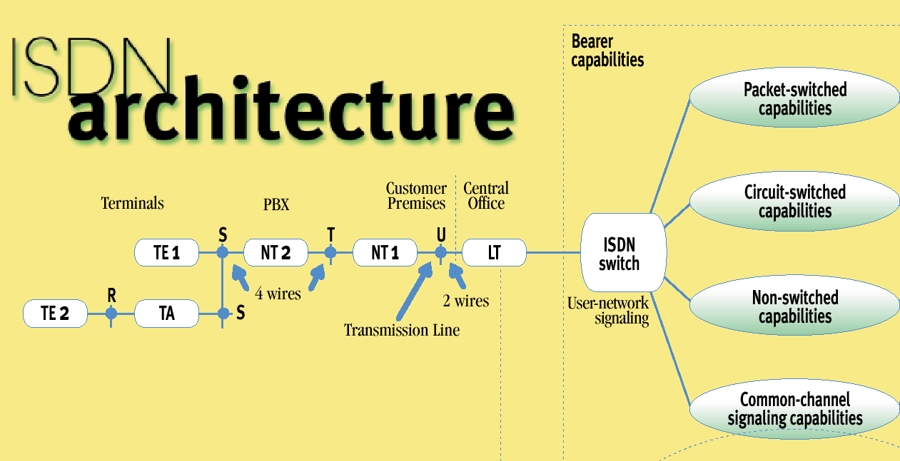
To transfer a bit rate of 2x64kb/s plus 16kb/s over the telephone line a base-band modem pair named Liner Terminator and Network Terminator is used. The transmission code 2B1Q needs the frequencies 0 to 80kHz on the telephone line.

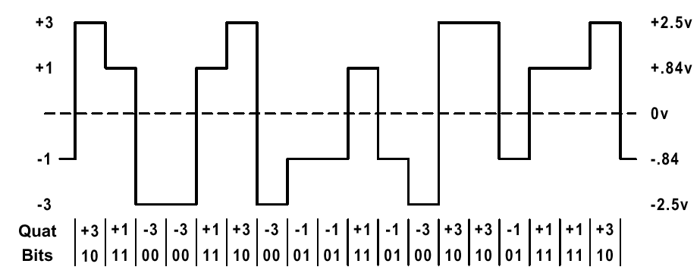

The Network Terminator is provided by the telecom company and offers an interface named S-Interface to connect telephones and other ISDN-devices
S -Interface
The S-Interface is a 4 wire interface using twisted wire pairs for transmit and receive direction.

Options of ISDN cabling
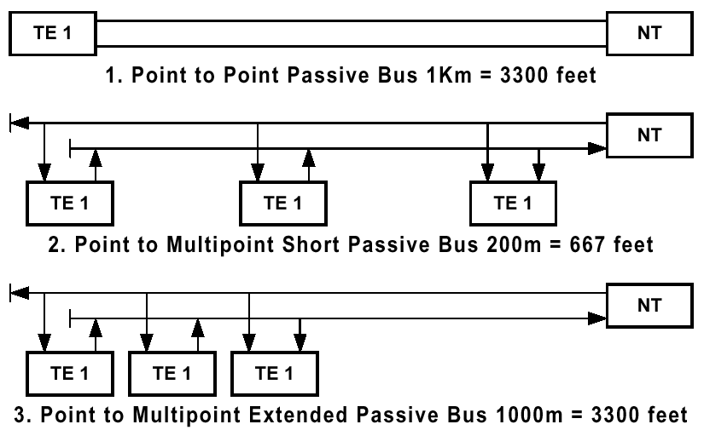
- Point to point
One terminal is connected to the NT
- Short passive bus:
Up to 8 Terminal-Equipments are connected to the NT via a bus-wiring. The bus has to be terminated on each end with 100 Ohm and the bus wire length is max. 200 meter
- Extended passive bus:
Nearly the same as the short passive bus but the network terminator is located in larger distance to the terminal equipments.
In this configuration distance between the Terminal Equipments to each other is limited to 50m
For b) and c):
  - Maximum TE connection cable length: 10m
  - Maximum NT connection cable length 3m
  - The bus has to be terminated by a resistor of 100 Ω.

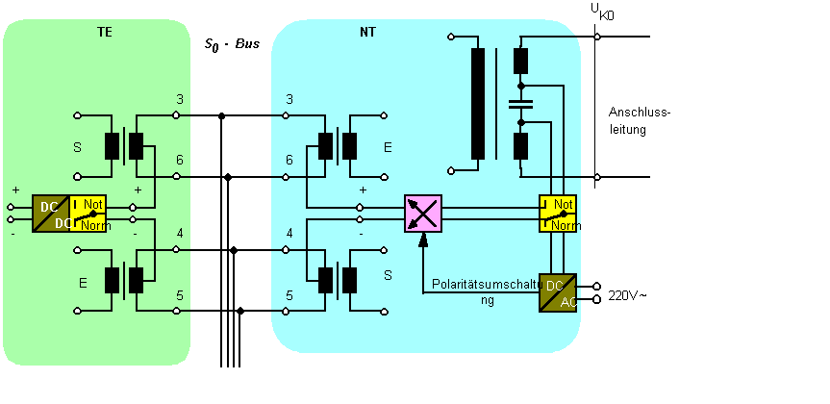
Power supply:
The NT needs a local power supply (230V) and powers all telephones connected to the S-interface.
In case of power a failure it is possible to sustain an emergency service. During emergency service NT is powered by the telephone centre and is able to supply only one telephone.
Polarity of power supply on the S-Interface is reversed to signal emergency situation.
The emergency telephone has to be configured so that it is marked as the one phone powered even in case of power failure.

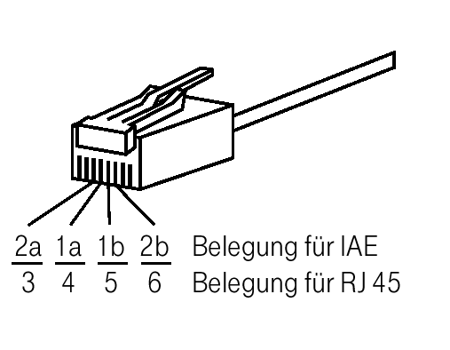
Plug:
Pin | TE | NT
1 | NC | NC
2 | NC | NC
3 | Transmit+ | Receive+
4 | Receive+ | Transmit+
5 | Receive- | Transmit-
6 | Transmit- | Receive-
7 | NC | NC
8 | NC | NC

Modular plug RJ45 is used.
The same plug used for Ethernet but with different wire pairs.

Line Code
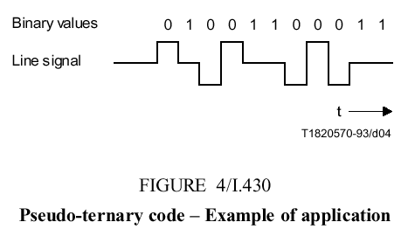
Inverse AMI (Alternate Mark Inversion is used. A Binary0 is represented by a voltage of +0.75V or –0.75V altering.
A binary 1 is represented by 0V.
The 0V during a binary 1 is resulting from TEs high impedance state during a 1.
Altering + and – grantees a DC-current free signal.

Transmission frame
the length of a transmission frame is 250µs

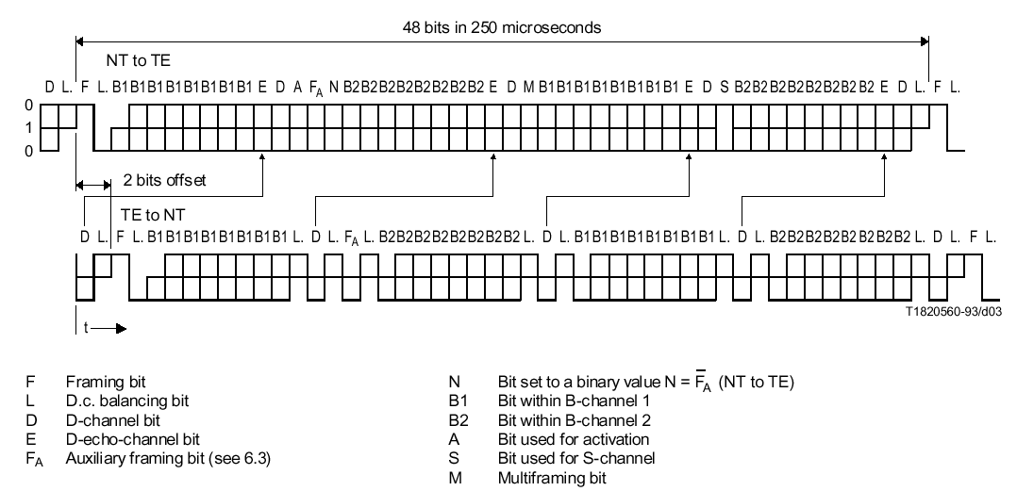
In this time 48 bits are transferred.
NT is the timing master generating the frames and the terminal equipment synchronize to that frames and send their frames with a delay of 2 bits.

Frame synchronization
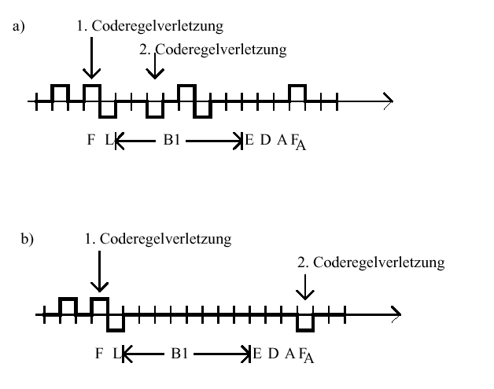
Frame synchronization is signalled by AMI-Code rule violations.
F-Bit is used for that purpose and has the same polarity as the pulse before.
To guarantee dc-current freeness a second code rule violation with opposite polarity (L-Bit) is sent after the F-Bit

Primary Rate Interface
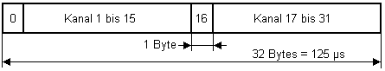
The primary rate interface provides 30 circuit switched B channels (30*64kBit/s) and one packet switched D-channel (64kBit/s).
Timeslot 0 is used for frame synchronization.

For Primary Rate interface only a point to point cabling is allowed.

Line code:
HDB3
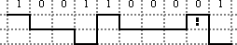
HDB3 is similar to AMI but with limited numbers of consecutive 0 allowed.
If more than 3 consecutive 0 would occur a artificial 1 is introduced and sent. This artifical 1 is eliminated by the receiver again.

Interface:
There are 2 types of interface in use:
- Unsymmetrical Interface:
A coaxial cable with impedance of 75 Ohm
- Symmetrical Interface:
Twisted pairs with a characteristic impedance of 120 Ohm.
ISDN-Services
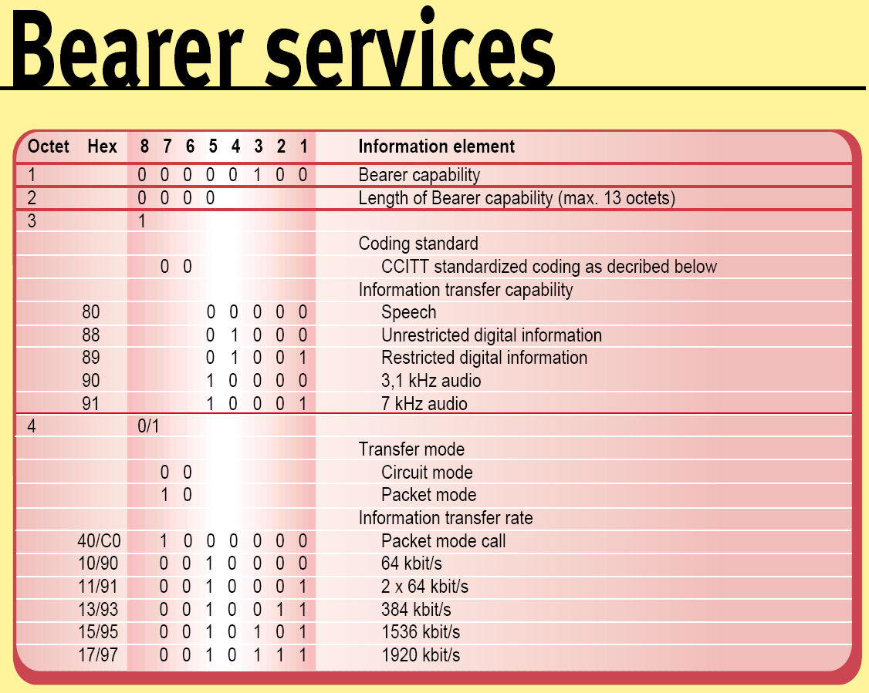

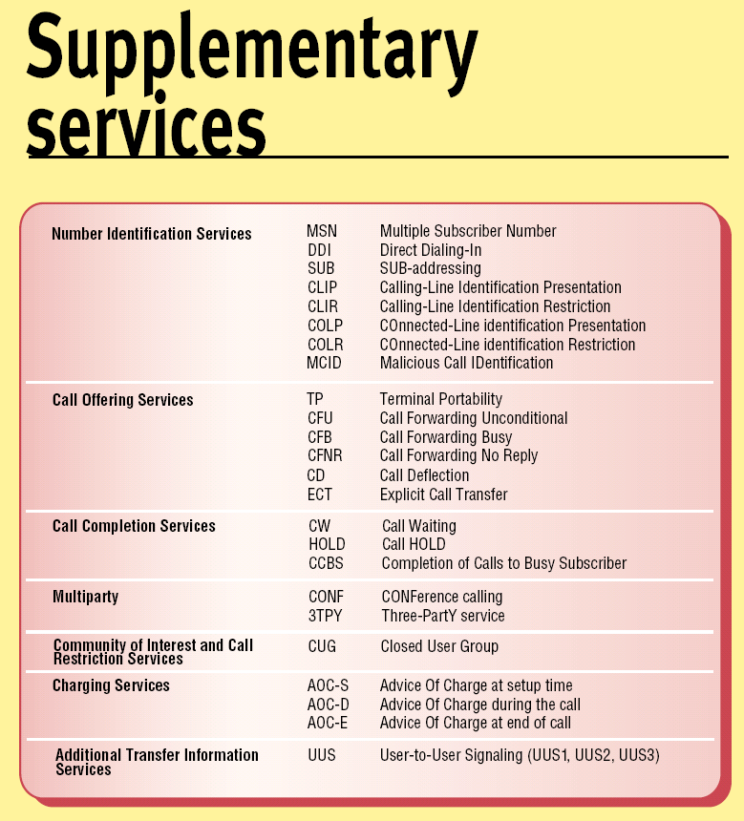

Exercises:

ISDN Layer1:
Measure the signal on transmit- and receive side of the S-Interface Bus using an oscilloscope during idle state and during an ongoing conversation.

Print out the transmission frame and mark the start and end of the frame.

Answer following questions:
- Level of the power supply voltage on the S-interface-bus
- Duration of a frame?
- Signal voltage?
- Bit length?
- Difference in the frames during idle state and conversation state?

